


2026 Call for Presenters

Purpose
Beyond Limits hosts an annual conference guided by person-centred values and informed by research and best practices. We come together to exchange ideas, expertise, experience, and knowledge with the goal of enhancing the quality and accessibility of services for people with support needs. For more information visit beyondlimitscanada.ca.

We welcome research, practice, and lived experience proposals for workshop sessions. Presentation topics related to clinical, educational, and social inclusion supports, technology, ethics, and advocacy are encouraged. Workshop proposals should include the key learning objectives, audience engagement strategies, and practical skills for attendees. Workshop sessions are 60 minutes long.

Theme – Designing the Future of Accessibility
Bringing together people, ideas, and experiences to explore inclusive solutions that remove barriers and expand opportunities. This theme centres collaboration, creativity, and lived experience to shape a more accessible future where everyone belongs.

Important Dates
April 6, 2026 - Deadline to email your submission to chair@beyondlimitscanada.ca.

June 26, 2026 - Successful submission applicants will receive an acceptance notification. We want to thank everyone for submitting. Due to schedule limitations, not all submissions will be approved.

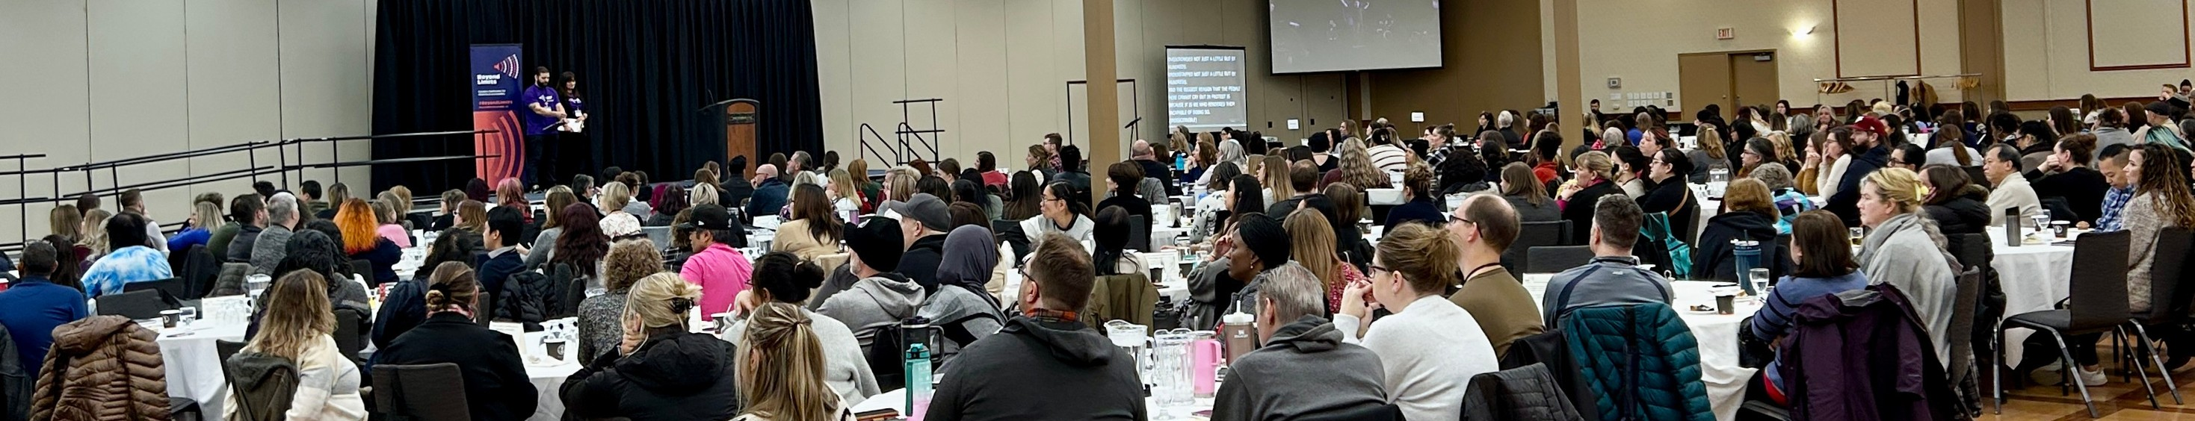
October 26, 2026 - Full day conference event, in-person at Victoria Inn Hotel and Convention Centre, Winnipeg, Manitoba.

Workshop Submissions
You can submit one of three ways:

Visit our website to complete the online form beyondlimitscanada.ca/call-for-presenters
Complete the PDF form and email to chair@beyondlimitscanada.ca Print, complete and mail this form to:
St.Amant, C/O Beyond Limits Committee, 440 River Rd,
Winnipeg, Manitoba, R2M 3Z9

Provide all information in plain language.
Presenters: List of presenter(s) and co-authors, and affiliations. Indicate who will be attending the event and presenting the workshop, and provide their contact information.

Name and affiliation | Presenting or Co-Author | Email | Phone

Presentation Title:

Presentation Abstract/Description: An overview of the purpose and intended outcomes for the session (maximum of 250 words):

Presenter Biography (200 words):

Target audience: Who will benefit from your presentation?

Lived Experience: How have the lived experiences of disability contributed to this workshop (maximum of 100 words)?

How does your presentation connect to our 2026 theme: Designing the Future of Accessibility?

Speaker/Presentation fees:

Please describe any travel and accommodation reimbursement requirements:

Presenter Responsibilities

- Provide presenter bio(s) and photo(s) within 14 days of acceptance notification.

- Workshops must abide by accessible and inclusive practices per the Accessibility for Manitobans Act. Accessibility guidelines are available on our website (pdf, Word).

- Registration fees are waived for approved workshop presenters. Presenters will still need to complete a registration form in advance to indicate any accommodation(s) or dietary requirements.
- Presenters requiring a support person, will have their registration fee waived. Registration fee(s) will apply to invited guests of the presenter. If cost is a barrier, please contact us at chair@beyondlimitscanada.ca for an accommodation.

- Arrival at the Victoria Inn Hotel and Conference Centre (Winnipeg, Manitoba) no later than one hour before your scheduled session.
- Disclosure of any financial or sponsoring sources.

