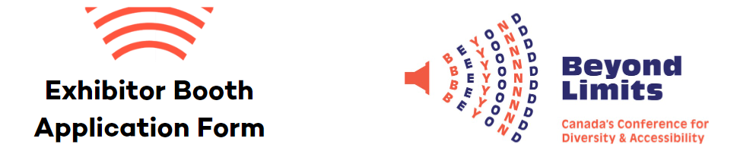

This Exhibitor Booth Application Form includes information on how you can support the Beyond Limits Conference, Canada’s Conference for Diversity & Accessibility, on October 26, 2026. Beyond Limits is a conference sponsored by St.Amant, a not-for-profit that supports adults and children with developmental disabilities, autism, and acquired brain injury in Manitoba, Canada. We are committed to providing meaningful and practical opportunities for professional development, networking, and advocacy. As a not-for-profit, we rely on and appreciate your ongoing support.

2026 Conference
Date and Location
- Monday, October 26, 2026
- Victoria Inn Hotel & Convention Centre, Winnipeg, MB

Theme – Designing the Future of Accessibility
Designing the Future of Accessibility invites professionals, advocates, people with lived experience, educators, and community leaders to reimagine what accessibility truly means when innovation, inclusion, and human-centered design come together to support real people and real communities.
This year’s theme challenges us to envision a future shaped by creativity, collaboration, and shared purpose. Together, we will explore emerging research, innovative practices, technologies, and ethical frameworks that expand opportunities and remove barriers across environments, reflecting our collective commitment to dignity, equity, and belonging.

Application Submission
Submission Date - Friday, September 11, 2026
Email your application form to info@beyondlimitscanada.ca. We receive many applications and have a limited amount of space. We thank everyone for applying. If your application has been selected and approved; you will receive confirmation and an invoice for payment.

About Us
beyondlimitscanada.ca
Society often puts labels on people with disabilities, which in turn limits their ability to thrive. Beyond Limits brings people together to exchange ideas, expertise, and knowledge with a goal of enhancing the quality and accessibility of services for people with additional support needs. We push beyond the limits of the possible into the impossible. It is here where we truly create a community of inclusivity, amplifying the voices of the people we serve.

Contact Information
Company/Organization: ____________________________________________________________
Website/Social Media Handles:_______________________________________________________
Contact Person Name:_________________ Email address: ________________________________
Cell phone number: ________________________________________________________________
(in case we need to reach you day-of) This number will be kept confidential and only used in case of emergencies

To enhance your application, please share:
How your organization connects with and supports the goals of the Beyond Limits Conference and the 2026 Theme:

Who you are hoping to reach by having an Exhibitor Booth at the Beyond Limits Conference:

Exhibitor Booth

$750 – Exhibitor Booth $400 – Non-profit Organization Exhibitor Booth
Includes:
- Company listed as a Conference Exhibitor on the Beyond Limits Website.
- Listed on handouts – Booth BINGO, for attendees visiting booths.
- Table will be inside the plenary room with access to keynote presentations.
- An opportunity to network with our 500+ attendees during breaks and lunch.
- Food and beverage for two people.

Do you require power at your booth? ($80 fee will apply) Yes No

Exhibitor #1 Full Name: _______________________ Email Address: _______________________
Exhibitor #2 Full Name: _______________________ Email Address: _______________________

Exhibitor Space
- The location of all booths is pre-determined. Check in at the registration desk upon arrival.
- An exhibitor booth includes one 6’ covered table with two chairs, access to WIFI, and optional power for an additional fee.
- Exhibitors can set up their displays as early as 7:15am on Monday, October 26. Conference participants are expected to arrive between 7:45am – 8:30am.
- Displays should be removed no later than 4:45pm on Monday, October 26.

Exhibitors are encouraged to remove all valuables when a representative is not present at the booth. Beyond Limits and the Victoria Inn cannot be held responsible for lost or stolen articles.

FAQ’s

Q – Is there a cancelation/refund policy?
A – If you have been confirmed as an exhibitor and need to cancel, please submit your cancellation request no later than three weeks before the event date. This deadline helps cover printing costs and venue table fees. Cancellations received within three weeks of the event are not eligible for a refund; however, you may send printed materials for us to display at your table, and your organization will still be recognized as an exhibitor.

Q - What can I expect as an Exhibitor on the day of the conference?
A – Registration starts at 7:45 am, though you can arrive as early as 7:15am. Find the registration table for exhibitors and you’ll be led to your booth within the main room. The program begins at 8:45, so we’ll ask that you are set up by then. Exhibitors will have access to the keynotes in the main room. During this time attendees will be seated and not networking, so you’ll have downtime for yourself or to listen. There will also be downtime during the breakout sessions. You’ll see the most traffic to your booth during our networking breaks and lunch. We will share agendas closer to the event date.

Q – What is Booth BINGO?
A – Booth BINGO is an activity we provide to attendees in their swag bag. They will take this Bingo Card and visit booths, complete the card and enter it into a draw to win a prize. Booth Bingo is designed to encourage attendees to visit booths, learn from each, receive resources and network. It’s also a benefit to Exhibitors, as attendees are motivated to visit each booth. Exhibitors are able reach attendees from a variety of organizations in a variety of positions. We ask that Exhibitors stamp attendees Booth BINGO card, with a Bingo dabber that we provide.

Q – What are the set up and take down times? Can I set up the day before?
A – Unfortunately, you cannot set up the day before. You can come as early as 7:15 AM to set up your booth. The event runs from 8:30 AM – 4:15 PM. Booths need to be taken down by 4:45 PM, on the day of the event, October 26.

Q – Is lunch included?
A – Yes. As part of the Exhibitor Booth fee, lunch is included for up to two people. You can report any allergies to your conference contact.

Q – When do I have to pay the invoice?
A – Please provide payment for the invoice within 30 days of receipt. You can also bring payment with you on the day of the conference.

Any questions you may have can be emailed to info@beyondlimitscanada.ca

